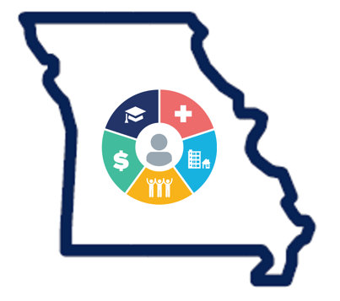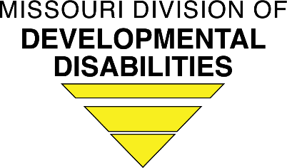
Division of Developmental Disabilities (DD) Health Home
New Director Checklist

The following list prioritizes responsibilities for incoming DD HH Directors. It is recommended for all new
Directors to discuss their individual needs and strategies with Donna Siebeneck, DD HH Program Manager/Enrollment Coordinator, Donna.Siebeneck@dmh.mo.gov, Shyla Brauch, Federal Programs Unit Program Manager, Shyla.Brauch@dmh.mo.gov, and Morgan Williams, MBHC Integrated Care Manager mwilliams@mbhc.org.

- Contact the Division:

For upcoming important meeting invites.

Initial Training (may be virtual)
- New Director Training
- DD HH 101
- Nurse Care Manager Training
- CareManager and Reports Training
- Relias Training

HIT user account set up:
- CyberAccess -Your agency CyberAccess Practice Administrator or Melissa Bishop, DMH CyberAccess Representative, Melissa.Bishop@conduent.com and Jessie Doughty, Supervisor with Delivery Government Healthcare Services Conduent Heritage LLC, Jessie.Doughty@conduent.com

- Relias Learning -Your agency human resources or training department.

- Monthly Team Log- https://hchteamlog.org Contact the CareManager help desk for setup help and any issues logging in at caremanager@mobhc.org.

- CareManager – Your agency CareManager System Administrator or the CareManagerHelpdesk: caremanager@mobhc.org

- CIMOR –Follow the link for new user request. https://portal.dmh.mo.gov/ CIMOR and Portal User Account Setup and Login Instructions
The following is the basic setup for new users and log in errors in the CIMOR and Portal applications.
- First, you will need an account to access the CIMOR or Portal page. A DMH User id can be requested and updated using the Contract Provider Access Request Form. This form is located on the DMH Portal page at https://portal.dmh.mo.gov.
- You will receive an email with the User ID (myxxxxx) and a separate email with your temporary password that must be reset at your first log on. You will have 21 days to change your temporary password. If the temporary password is not changed within the first 21 days your account will be disabled and you will need to call the help desk to get the account enabled.
- You will need to go to the portal page https://portal.dmh.mo.gov. It is recommended that this page be added to your favorites, as you will need to come back to it often.

For further questions or concerns, contact the CIMOR help desk CSC@dmh.mo.gov.

- sFTP –To gain access to the FTP site you can:
- Go to the DMH portal page: https://portal.dmh.mo.gov/
- Click “Please log in”
- Type in Domain\Username and password

- Click “Log in”
- Click on “Apps-Docs-Videos”
- Type in Username and password
- Click “Log in”
- Click on the folder with your agency’s sFTP number
If you do not have access to do this, you need to either put in a help desk ticket (mzcimordbhsupport@dmh.mo.gov) or speak with your agency’s local security officer.

- IntellectAbility (IA) HRST-To gain access to this system, your agency will need to designate at least one HRST Gatekeeper. The process to request DD HH Gatekeeper access to the system is through a direct email to MODDHRSTProject@dmh.mo.gov with subject line Request for DD HH Gatekeeper. Upon receipt of the email request, the Division will work directly with IntellectAbility support staff to create the DD HH Gatekeeper account. Once the account is created the Gatekeeper will receive a direct email with instructions to set up their unique password and login for the system. Upon gaining access, the designated Gatekeeper will complete a 15 minute training within the IntellectAbility system. The online tutorial will instruct the Gatekeeper on how to:
- Request other gatekeeper user accounts
- Change the status of an existing gatekeeper account
- Request standard user accounts
- Change the status of an existing standard user account
Upon completion of the training the Gatekeeper will then have the ability to request accounts with IntellectAbility for the remaining users in their agency.
Once a DD HH team member has been to receive access to the system through their designated Gatekeeper the team member will receive a direct email with instructions to set up their unique password and login for the system. Upon gaining access, the designated team member will complete their assigned training in their training library before gaining direct access to the live system.
When existing gatekeepers create other gatekeeper accounts in the application, the gatekeeper will attest that the new gatekeeper has been approved to serve in this capacity by the agency Director.

- Review DD HH Provider Operations Manual

- DD HH Director Mentor:

Donna Siebeneck and Shyla Brauch will pair the new DD HH Director with an established DD HH Director as a mentor.

Phone/email contact with mentor

Initial virtual meetings to discuss questions/concerns. In person meetings may be arranged if mentor and mentee agree it would be beneficial.

Schedule regular ongoing contact.

- Get to know the DD HH:

DD HH Provider Operations Manual

State Plan Amendment (SPA)

Code of State Regulations (CSR)

Staffing requirements

DD HH Forms

CMS Six Core DD HH Services

DD HH deadlines and reporting processes such as:
- DD HH Monthly Team Log (MTL)
- Attestations in CyberAccess
- Population Health Management Attestation File
- Hospital Discharge and Medication Reconciliation

Payment processes, PMPM, retro-payments, reject payments.

CareManager System

IntellectAbility System

- Get to know the DD HH Population (Division, MBHC, and mentor will assist):

Reports and Measures Results to Review:
- Hospital Follow Ups (including Medication Reconciliation)
- MBS Completion
- PCP Status Summary

CyberAccess Attestations

Documentation Requirements
- DD HH Health Screen, Medication List, Progress Notes
- Electronic Health Record MBS entry or direct entry to CareManager is required.
- DD HH Plans include Nurse Care Manager (NCM) signature and health goals match the individual’s health screen.
- What constitutes a service for a PMPM payment?

Enrollment, Transfer, Discharge process and forms

Contact Profile Form

- Useful Websites:
- CIMOR–https://cimor.dmh.mo.gov/CIMORLogin.aspx?ReturnUrl=%2f
- Cyber Access Log on page–https://www.cyberaccessonline.net/cyberaccess/Login.aspx
- DD HH Webpage –https://dmh.mo.gov/dev-disabilities/health-home
- MO HealthNet Provider Manuals–http://manuals.momed.com/manuals/
- MO HealthNet Provider Bulletins–https://dss.mo.gov/mhd/providers/pages/bulletins.htm
- sFTP DMH Portal–https://portal.dmh.mo.gov/Account/Login

