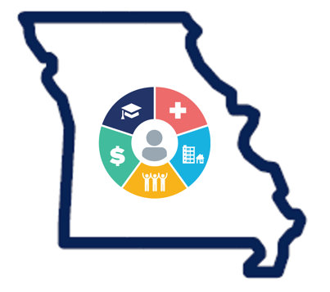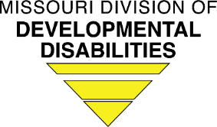
DD Health Home Team
Contact Profile Form

Please complete this fillable PDF form and email to the Division of DD Program Manager/DD HH Enrollment Coordinator at DDHHEnrollTransferDischarge@dmh.mo.gov. This form must be completed for all new DD HH hires. Staffing changes must be reported to the Division of DD within (7) business days of a vacancy or filled position.
Please indicate your role on the DD Health Home Team:
DD HH Director DD HH Nurse Care Manager
DD HH Physician Consultant/APRN DD HH Specialized Healthcare Consultant
DD HH Facilitator Other
Effective Start Date
Name:
Credentials
Agency
Site/Location(s): (if applicable)

Primary Work Address:

Street

City Zip

Email:

Direct Work Phone: ext.

Fax Number:

* Do you need to be placed on the email list to receive hospital notification alerts?

Yes No
_____________________________________________________________________________________________

Please make sure that you have a user account for the following online tools. Please contact the appropriate program representative if you need to create a user account.

Cyber Access Your agency CyberAccess Practice Administrator or Melissa Bishop, DMH CyberAccess Representative, Melissa.Bishop@conduent.com and Jessie Doughty, Supervisor with Delivery Government Healthcare Services Conduent Heritage LLC, Jessie.Doughty@conduent.com
.Relias Learning Your agency human resources or training department.

CareManager To create a user account, please contact your agency’s CareManager System Administrator or the Help Desk (caremanager@mobhc.org).

