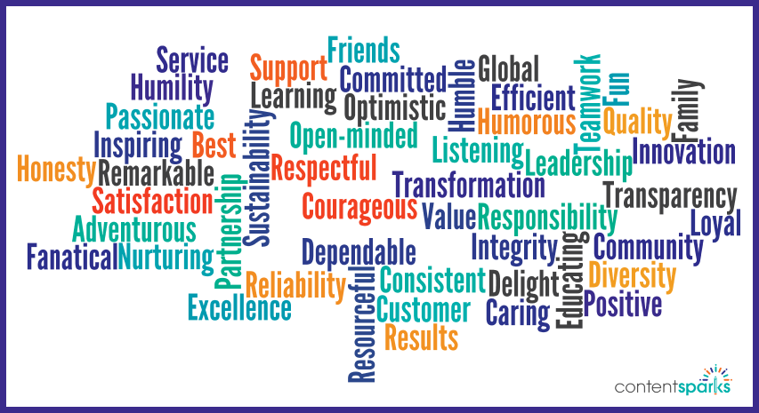
What Are Agency Values?
They describe the fundamental beliefs of a company or organization which will steer behavior, beliefs, and standards for conduct in all situations.

- The best Agency Values are:
  - Sincere
  - Rooted in what your company unwaveringly believes in
  - Direct outgrowth of an agency’s vison and mission
  - Guide in decision making, strategizing, and in prioritizing of tasks
  - Act as a moral compass

- Life values are guiding principles-valued behaviors and attitudes for success in life.
  - 1) Broad constructs or classes of behavior
  - 2) Positive and inspiring
  - 3) Brief-no more than three to five in number
  - 4) Comprehensive, i.e. they allow you to address all behaviors by referencing one of them. Key Points to consider

- Agency-wide Life values reflect the language and culture of each agency. They will become the language all staff use when they train, recognize and teach desirable behavior within their organization.
  - Ex. Being respectful, Being knowledgeable, and being kind. “Our agency believes it is important to respect all people and their property.”
- It’s important for management to be cheerleaders for their Agency-wide values and promote them
- Use of Agency values provide guidelines for individuals to monitor their own behavior, as well as remind and motivate individuals to meet certain standards
Many agencies choose to use an acronym to describe their Agency Values. See below for an example
H.E.A.R.T.

HONORED-
LIVNG A LIFE OF HONOR, RECOGNIZNG THE VALUE AND PURPOSE OF LIFE WITHN OURSELVES AND OTHERS

EMPOWERED-
CREATNG MOMENTS THAT MATTER AND EMPOWERNG PEOPLE TO CHOOSE
AND LIVE AN HONORABLE LIFE

ACCOUNTABLE-
ACCEPTNG RESPONSIBILITY OF EMPOWERED LIVNG

RESPECTED-
BEING ACCOUNTABLE TO TREAT OTHERS WITH RESPECT

TEAM PLAYER-
INTERACTRNG RESPECTFULLY WITH OTHERS THROUGH COMMUNICATION AND COOPERATION TO ACHIEVE A COMMON GOAL



Defining Agency-Wide Expectations

Once 3-5 values have been selected, you are ready to move to the second level.
Defining each of those values more specifically.

Behaviorally Defined Expectations are the specific criteria for meeting life value outcomes.

TO-DO Terms:

- Action verbs
- A single specific action, rather than “big Ol’ categories” (ex. “not” doing something)

Expectations developed meet:

- Specificity should leave no doubt for staff or individuals to know exactly what “To Do”
- Here you are answering the question, “What does [respect, responsibility, best effort, etc.] look like in all settings [at work, in the home, in the car, in the community, in the kitchen, etc.].
- The task is proactive—what do successful individuals do?
- Encourage positive behaviors, and are proactive to prevent problem behaviors.

OMPUA

Observable | I can see it
Measurable | I can count it
Positively Stated | Explain and tell what “TO-DO”
Understandable | Vocabulary is age appropriate
Always Applicable | Something all staff will consistently apply

Agency-wide Life Values for All Settings
Most agencies begin by clarifying specific behaviors for all settings. These are behaviors that are expected across all environments the individual and staff will encounter. Below are some examples of how agency-wide life values have been defined for all settings.
Value | Office | Home / Program | Vehicles
CARING | Politely greet people, “hello,” “how is your day,” | Support housemates -- | Keep hands in your own lap when the vehicle is moving
RESPECTFUL
MOTIVATING

Sources:
(2020) Learning System Missouri Schoolwide Positive Behavior Support – Assisting schools and districts. (2020). Retrieved 17 June 2020, from https://pbismissouri.org/what-is-swpbs/
(2020). Retrieved 17 June 2020, from https://www.samford.edu/departments/files/Human_Resources/how-to-write-performance-expectations.pdf
(2020). Retrieved 17 June 2020, from http://pbismissouri.org/wp-content/uploads/2018/04/4E-Handout-2-Effective-Practice-2-Procedures-and-Routines.pdf

