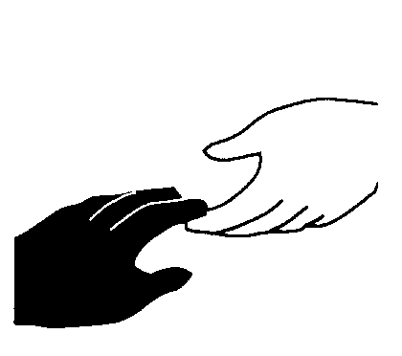
MEMBERSHIP APPLICATION
HELPING HANDS OF SOUTHEAST MISSOURI MENTAL HEALTH CENTER

Name: Do you
Address:
City:
Zip Code:
Phone:
E-Mail:

I am interested in helping to work in the areas of:
Auxiliary member
Fundraising
Community education
Advocacy for persons with a mental illness
Hospital volunteer
Other
I am available to work from: am pm to: am pm on Monday Tuesday Wednesday Thursday Friday Saturday Sunday
Additional Comments:

Please complete and send to:

Helping Hands of SMMHC
1010 W. Columbia Street
Farmington, MO 63640-2997

Phone: (573) 218-6792
Fax: (573) 218-6703
Email: susan.lindsey-schultz@dmh.mo.gov

Phone: (573) 218-6792
Fax: (573) 218-6703
Email: susan.lindsey@dmh.mo.gov
Helping Hands of SMMHC
1010 W. Columbia Street
Farmington, MO 63640-2997
Please complete and send to:

