 | Missouri Alliance for HOME CARE
2420 Hyde Park, Suite A, Jefferson City, MO 65109-4731 ▪ (573) 634-7772 ▪ (573) 634-4374 Fax

July 13, 2017

Bobbi Jo Garber
Mo Dept of Health & Senior Services
Jefferson City, MO 65109

Dear Bobbi Jo

This is in response to your email dated July 7, 2017 announcing the Business Acumen Learning Collaborative. We would be pleased to join DHSS in applying to be a part of the Disability Network Business Acumen Learning Collaborative.

Please consider this our letter of commitment and confirmation of our level of commitment that the Missouri Alliance for Home Care is willing to provide, to the best of our ability. We will be identifying two representatives from MAHC who will agree to attend national meetings (based on timing and funds available) and to participate in monthly technical assistance calls.

As you know, MAHC is a membership organization that serves over 250 home care companies that provide health care services in the homes of Missourians. MAHC provides home care companies & home care professionals with education, advocacy, news and information, resources and tools. MAHC participates in advocacy for all types of home care and hospice and assists home care providers with regulatory, legislative and reimbursement issues.

We consider our members to be part of the evolving service delivery system and knowledgeable and experienced in serving people with disabilities and the frail elderly. As an organization, MAHC has strived to assist our members in learning the most recent techniques and strategies in order to develop the necessary skills to provide care to all types of clients, including individuals with developmental disabilities who are aging and those with mental illness.

We believe we would be a good fit for the Business Acumen Learning Collaborative and appreciate being invited to participate. We are looking forward to the opportunity.

Sincerely,
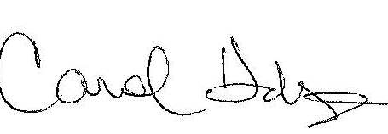
Carol Hudspeth
Executive Director

