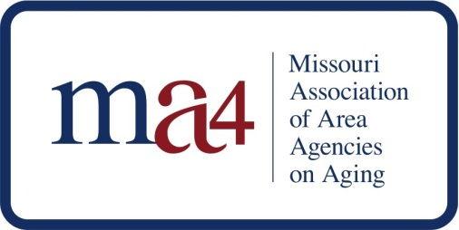
P.O. Box 104296
Jefferson City, MO 65110

July 10, 2017
Bobbi Jo Garber, Deputy Director
Division of Senior and Disability Services
Department of Health and Senior Services
930 Wildwood
P.O. Box 570
Jefferson City, MO 65102-0570

Dear Ms. Garber:

On behalf of the Missouri Association of Area Agencies on Aging (ma4), I am pleased to provide this letter of commitment to join with you in applying to be a part of the Disability Network Business Acumen Learning Collaborative. We are interested in joining a state team to work together to develop and implement business-related strategies to state-specific challenges to integrating long term services and supports and healthcare services. MA4 has undertaken several steps already to develop business acumen so that we are prepared to work within a changing funding environment.

MA4 is prepared to provide representatives to participate in national meetings, as well as monthly technical assistance calls. We could then share this information with the aging network at the Board’s monthly meetings, in work groups and at our annual summit. We are particularly interested in strategic business planning, organizational culture change, pricing and packaging services, marketing and sales strategies to integrated care entities, communicating and negotiating with health care providers/plans, quality (e.g. defining and measuring outcomes), accepting and managing risk and Information technology strategies.

MA4 and its member Area Agencies on Aging (AAAs) recognize that to meet the needs of the growing number of seniors in the future, new approaches and mechanisms are crucial. Public funding can no longer be the mainstay of support for this work.

MA4 looks forward to being part of this state-wide collaborative on business acumen. Please do not hesitate to contact me if you require additional information.

Respectfully,

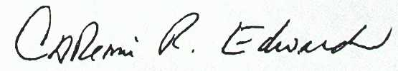
Catherine R. Edwards, Ph.D.
Executive Director

