July 13, 2017

Wendy Witcig
Deputy Director, Community Operations
Missouri Department of Mental Health
Division of Developmental Disabilities
1706 East Elm Street
Jefferson City, MO 65101

Dear Wendy,

Easterseals Midwest welcomes the opportunity to participate in the Disability Network Business Acumen Learning Collaborative. We recognize the critical juncture for services and supports for people with intellectual/developmental disabilities in our country. The impact of increased needs and expectations of people with intellectual/developmental disabilities, expanding regulations and limited financial resources most certainly, now, more than ever require stakeholders to work together and work differently. Organizations committed to serving people with intellectual/developmental disabilities must learn to integrate services, evaluate outcomes and create efficiencies to achieve their mission. Our strategic plan, approved by the Easterseals Board of Directors on April 20, 2017, specifically includes "conduct an ongoing needs assessment of new and growing markets," "develop the sustainable agency infrastructure needed for continued growth" and "identify the data needs and strategies necessary for long-term success."
Easterseals Midwest has a long history of collaboration as a strategy to develop competencies and serve more individuals in need. This business acumen initiative provides the opportunity to prepare for the future. We have previous experience working with Easterseals organizations across the country to find ways to meet the challenges and opportunities ahead of us.
Easterseals Midwest will commit the time of the executive leadership staff as necessary to participate in this project including travel in the state as well as outside of Missouri. I am registered to attend the HCBS Conference in Baltimore. Having attended this conference in the past, I understand the benefits from the materials and learning from other attendees. I look forward to supporting the Disability Network Business Acumen Learning Collaborative.
Sincerely,
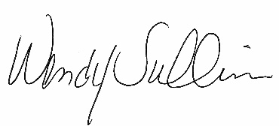
Wendy Sullivan
Chief Executive Officer

