Understanding the Movement Toward Managed Care

Increase costs to Medicaid

Increase costs in Medicaid are driven by populations served in LTSS. A study in the Medicare population shows that Medicare pays almost three times as much per capita on the 13% who need LTSS. Even when age, chronic conditions or Medicaid eligibility are controlled for, LTSS is the consistent factor associated with increased spending. Since Medicaid is the only public funding program that pays for LTSS, it would be interesting to see the comparison with spending for Medicaid LTSS in Missouri.

These facts have pushed CMS to look into factors that drive higher costs for people in LTSS.

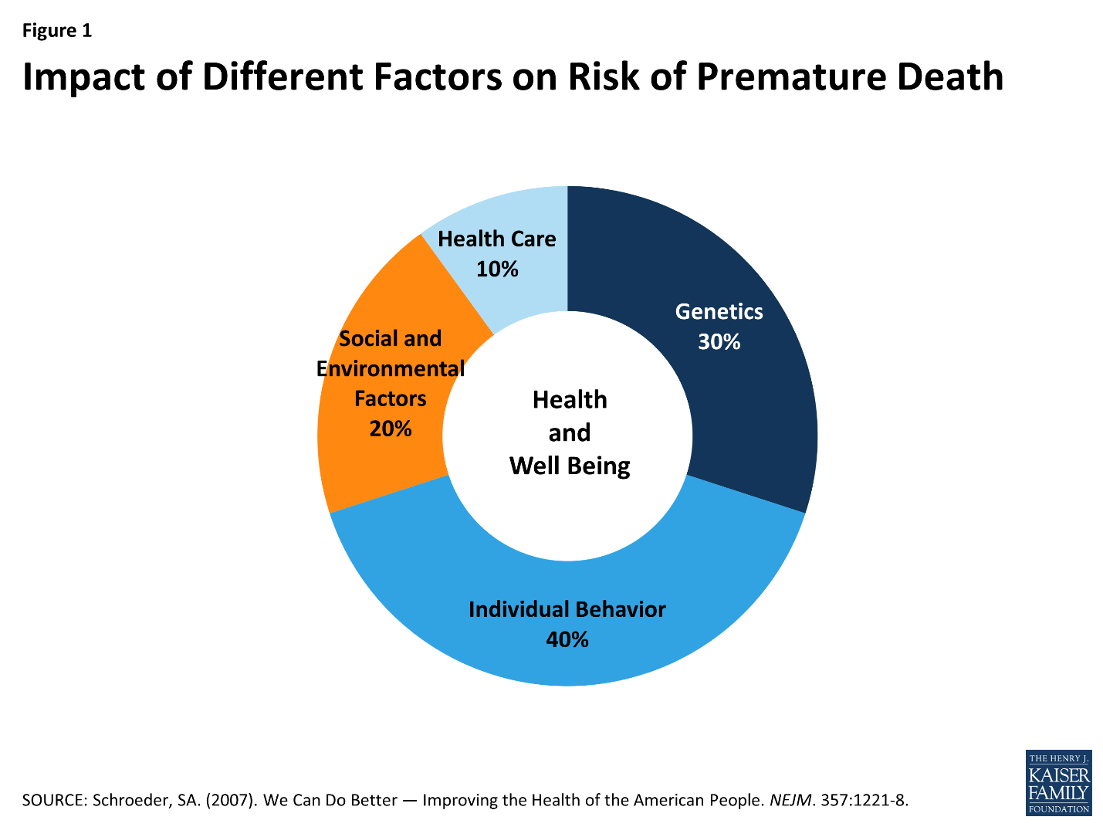

Through our service delivery system, we can have an impact on 60% of factors that create risk for premature death; Individual Behavior and Social and Environmental Factors.

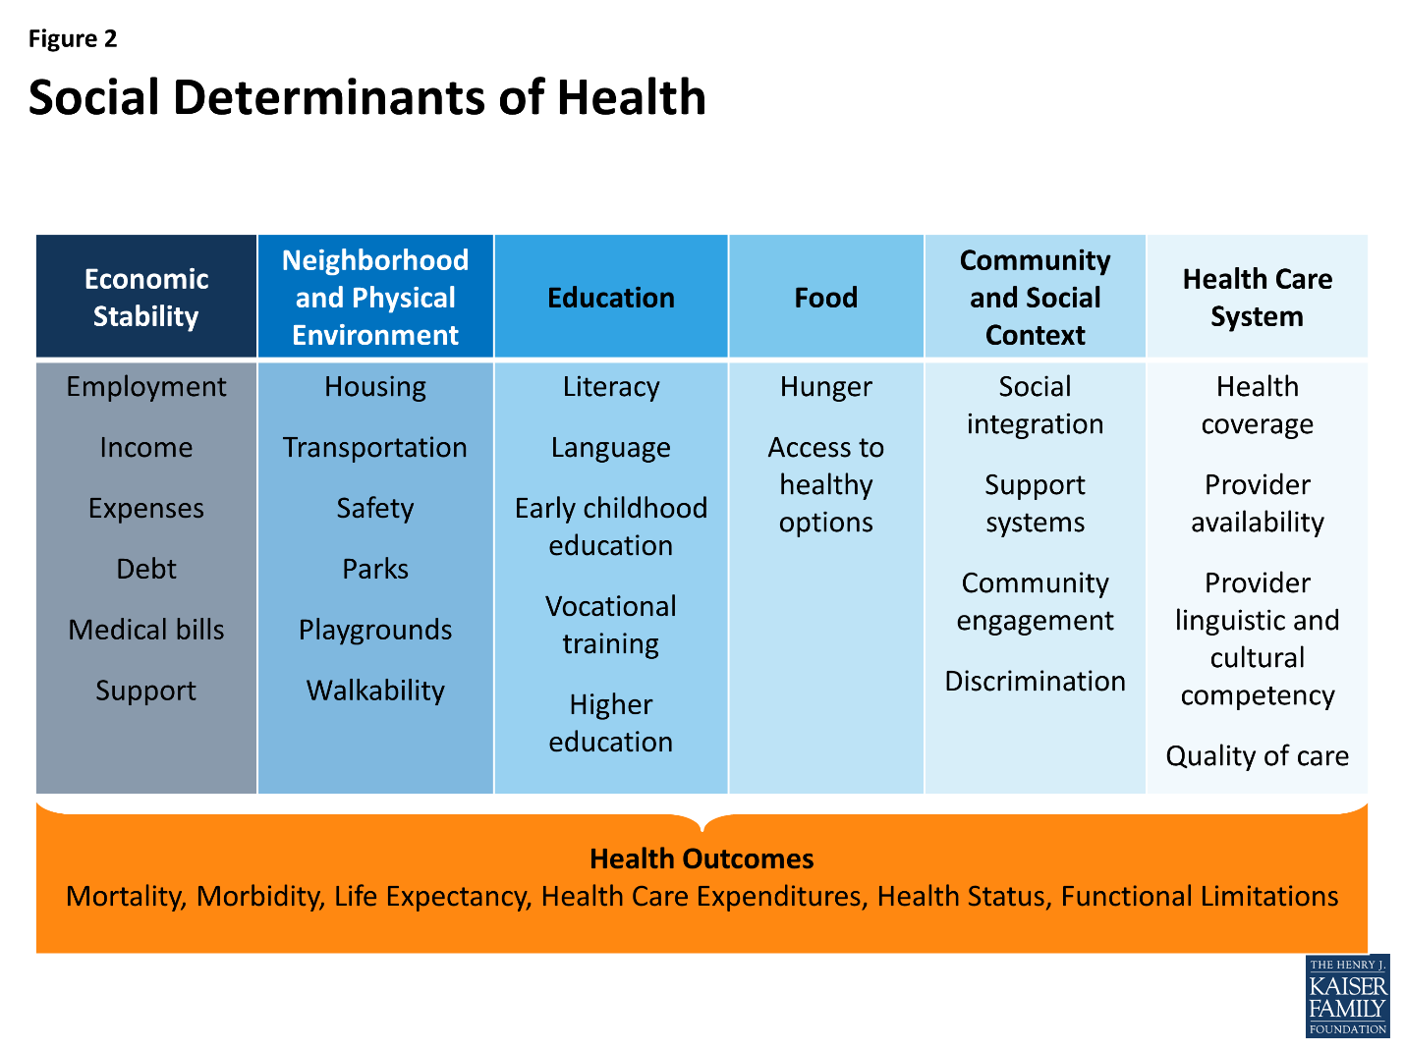

Understand why states are moving to managed care.

Goals for Managed Care
- Rebalance LTSS spending toward HCBS and provide more options for people to live in the community. May be driving factor for states with high institutional populations – including nursing homes.
- Improve member experience, quality of life and health outcomes.
- Reduce waiver wait list and increase access.
- Increase budget predictability and manage costs. Providers may interpret to mean cutting rates and limiting services. FL, MA and TX reported a cost savings through decreased administrative burden.

Impact of cuts in Medicaid through block grants or per capita caps. We have to figure out how to meet the need if resources are limited.

Opportunity stay in touch with what is going on in managed care and industry across the state.

What problems/issues could MC solve for providers?

Why Business Acumen Learning Collaborative

Even though Missouri is not pursing moving to a managed care arrangement, there are many good practices that have come out of managed care that we could benefit from replicating. This is an opportunity for us to begin building some of those practices outside of a managed care format and provide foundational skills for state and providers if managed care comes to Missouri in the future.

