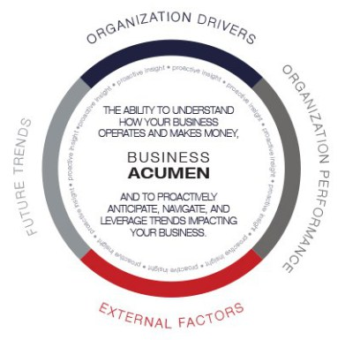

**HEALTHCARE**

THE ABILITY TO UNDERSTAND   
HOW HEALTCARE OPERATES   
AND MAKES MONEY