Volunteer Application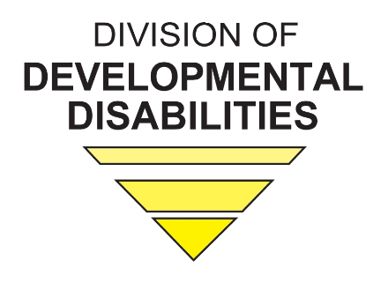

Name:

Address (Including City, State and Zip Code):

Contact Number:

E-mail Address:

What is your preferred method of communication (e-mail or phone)?

Check all that apply.
I am an individual living with a developmental disability.
I am a family member of an individual with a disability
I currently am employed by an agency who serves individuals with a disability.
I have an interest in volunteering to work with individuals with a disability.

Please state why you would be a good candidate to participate in a work group?

List three qualities you possess that would make you a good candidate for a work group.

Why do you want to be a part of this team?

Please state if you are currently participating in any committees, agency groups, or agency boards.

In addition to this application, please include a resume. Applications and resumes may be sent to ddmail@dmh.mo.gov or the Missouri Department of Mental Health, Attn: Division of DD, 1706 E. Elm, Jefferson City, MO. If you have questions, you may contact the division at 573-751-4054.

