CONNECTING TO THE
DEPT OF MENTAL HEALTH’S SECURE FTP SITE

Below is how to connect to the Dept. of Mental Health’s secure FTP web site (DMH File Transfer) through the DMH Portal.

We have a link on our portal home page (https://portal.dmh.mo.gov). Log in then under Apps-Docs-Videos click the link called DMH File Transfer. This link will prompt you to provide your DMH userid and password then will take you to our Secure FTP site which is the location for downloading reports or uploading electronic billing files. You do not need any additional software on your computer to connect.

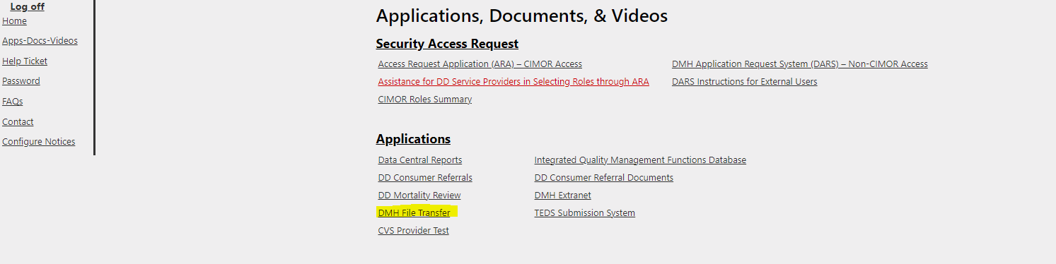

Navigation
When signing onto the File Transfer website you would normally just see the My Folders folder. You can click on the My Folders folder to view a list of numeric folders that you have access to. Scroll down to the provider folder number you want to view files for and click on it and continue to click on folders to drill down to the folder you are wanting. To go back you can click the ‘Back button to go to the previous folder level or you can click the ‘My Folders’ button to return all the way back to the beginning.

Uploading
If you wish to upload a file, please navigate to the correct folder such as /CimorProd/In/5010_837/ and then click the ‘Upload’ button. You can then navigate and select the file to be uploaded. Once the file is selected, click the Upload button.

Downloading
To download files from the FTP site, navigate to the location of the files and click on all files you want to download. Click the Download button. The file will be saved into your Downloads folder with the same file name and format that you see on the FTP site.

***NOTE: You may see some or all of the following subfolders under your organization’s individual folder:
CimorProd: Used for batching electronically to Cimor.
COSIG
GAIN
Reports: Contains OHCDS reports and other reports.

TECHNICAL SUPPORT
If there are any problems with the previous steps, contact the Dept. of Mental Health’s Customer Support Center at 888-601-4779.

NOTE: If you are getting access denied errors, or failed login errors, you may not have permission to your folder. You will need to submit a Security Access form if you have not done so already.

