**Future Experiences**

LIST current & future activities / experiences that would help keep moving your team forward.

**Past Experiences**

LIST past team experiences and events that moved you toward good outcomes.

**What is our Aim for a Successful Learning   
Collaborative Experience in our state?**

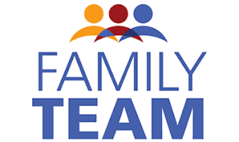

Kick-Off Meeting

October 2017

LIST team activites / experiences to avoid because   
they push you toward things you don’t want.

LIST past team experiences to that pushed   
you toward things you don’t want.

**What We Don’t Want for our Learning   
Collaborative Experience to become in our state?**

**_________________ State Team’s Vision for a Successful  
Disability Business Acumen Learning Collaborative Experience**